***ITF Project***

**Surface Approximation**

**Installation Tutorial**

[Sinara YANG](mailto:sinara@ust.hk) (Meshmixer API & iRANSAC)

[Chenxi FENG](mailto:cfeng@connect.ust.hk) (CATIA optimization)

[Min DENG](mailto:mdengaa@connect.ust.hk) (Drawing Automation)

July 28, 2018

**Contents**

[**1.Installation environment** 3](#_Toc520554277)

[**2.Preparation** 3](#_Toc520554278)

[**3.Steps** 10](#_Toc520554279)

[**1)** **Surface Approximation** 10](#_Toc520554280)

[**a.** **Meshmixer API** 10](#_Toc520554281)

[**b.** **iRANSAC** 15](#_Toc520554282)

[**c.** **CATIA optimization** 22](#_Toc520554283)

[**2)** **Drawing Automation** 29](#_Toc520554284)

[**a.** **Prerequisite conditions** 29](#_Toc520554285)

[**b.** **Outputs of the program** 38](#_Toc520554286)

# **1.Installation environment**

Windows 10 pro

64 bit OS

# **2.Preparation**

1. Extract ITF.zip into any directory (In this tutorial we take **D:\** for example)

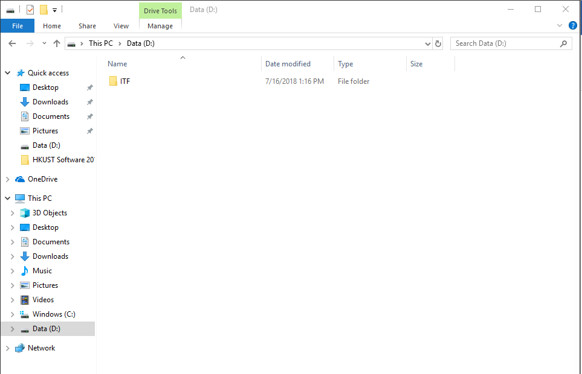

1. Go to [Control Panel] -> [System and Security] -> [System], click [Advanced system settings].

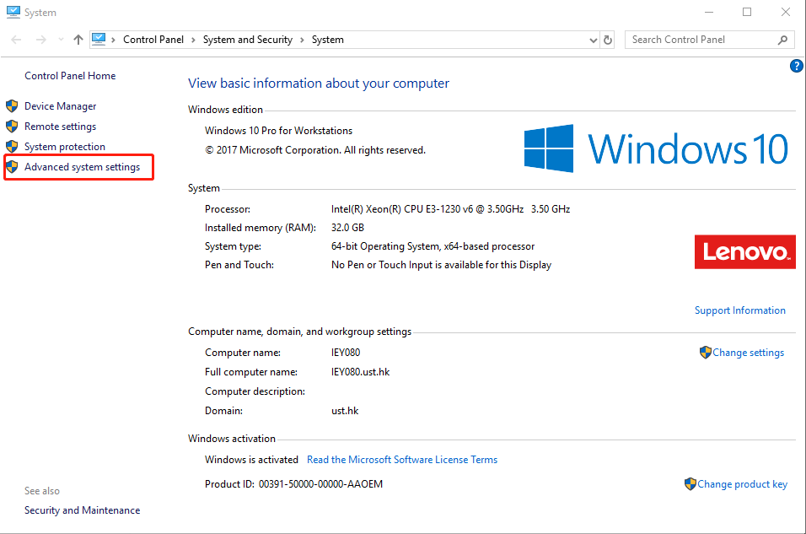

Click [Environment Variables] -> [New…]

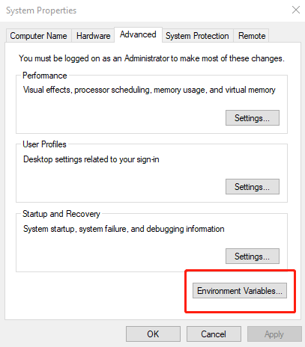

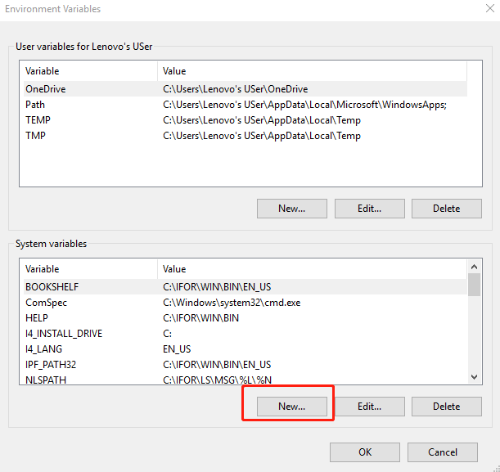

Add [Variable Name]: ITF and [Variable value]: D:\ITF (the directory that you extract ITF.zip into) and then click [OK]

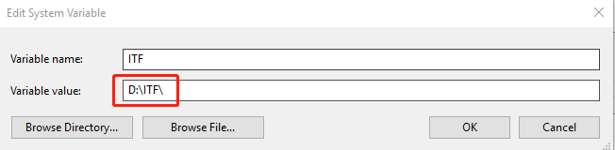

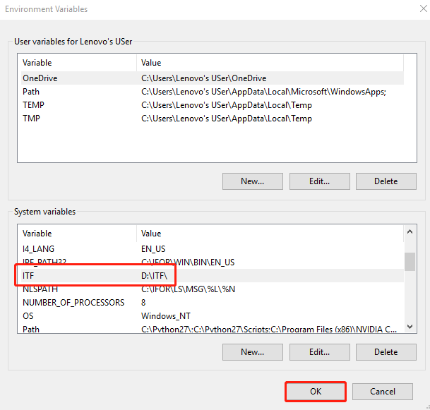

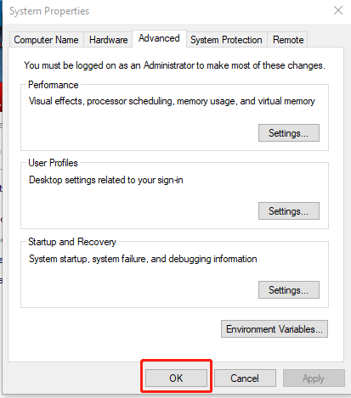

# **3.Steps**

## **Surface Approximation**

### **Meshmixer API**

* Go to D:\ITF\Surface\_approximation\installation\_packages\meshmixer\, use

Autodesk\_Meshmixer\_v3p5\_Win64 to install meshmixer software,

python-2.7.14 to install python,

vs\_ultimate\_2012 to install visual studio 2012,

PTVS 2.1.1 VS 2012 to install python tools for VS2012,

pywin32-219.win32-py2.7 to install pywin32,

py2exe-0.6.9.win32-py2.7 to install py2exe

in your computer (default setting).

* Then you can go to D:\ITF\Surface\_approximation\meshmixer\_API\python\, open mm solution.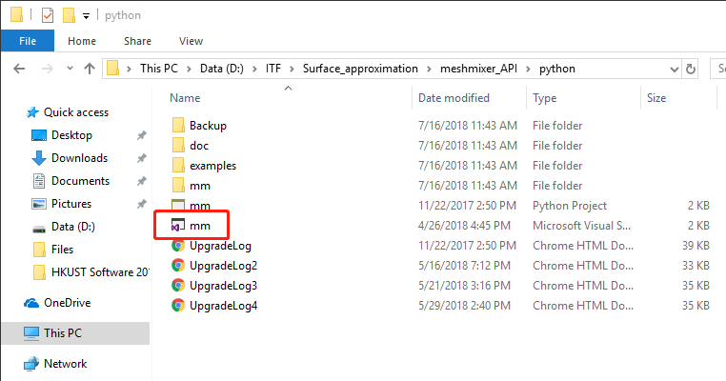

The remesh.py is the code we use to call meshmixer API to remesh panels.

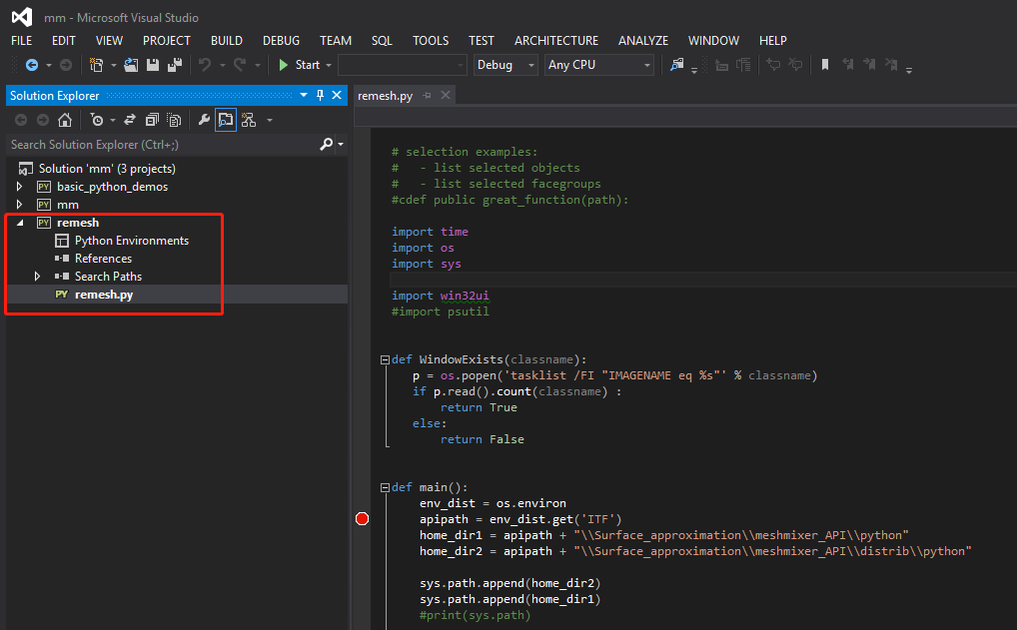

You must open meshmixer software before you click “Start”.

* If you change some codes in remesh.py, you should re-generate your new exe to use it in the next steps. If you would like to re-generate exe, there are two methods:

1. You need to go to D:\ITF\Surface\_approximation\meshmixer\_API\remesh\, both press Shift button and right click your mouse in the white area and click “Open PowerShell window here”. 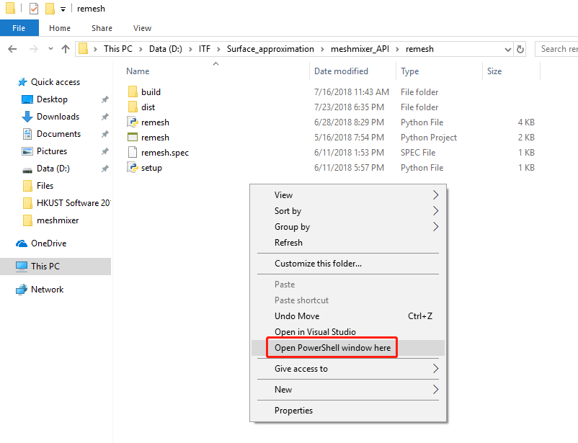

Input “python setup.py py2exe” to re-generate remesh.exe file in

D:\ITF\Surface\_approximation\meshmixer\_API\remesh\dist\remesh.exe.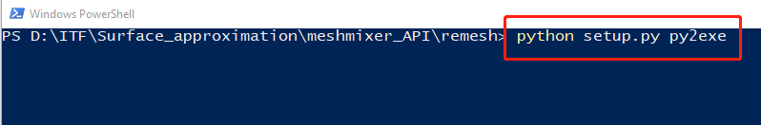

1. Open Command Prompt, go to D:\ITF\Surface\_approximation\meshmixer\_API\remesh, input “python setup.py py2exe”.

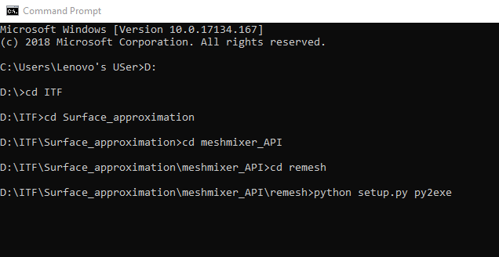

Go to D:\ITF\Surface\_approximation\meshmixer\_API\remesh\dist\, open meshmixer software and then input “remesh”, the program can remesh all the panels automatically.

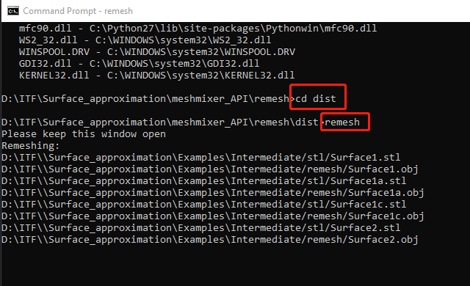

### **iRANSAC**

* Go to D:\ITF\Surface\_approximation\installation\_packages\, use

en\_visual\_studio\_community\_2013\_with\_update\_5\_x86\_6816332 to install VS2013,

PCL-1.8.0-AllInOne-msvc2013-win32 to install PCL library,

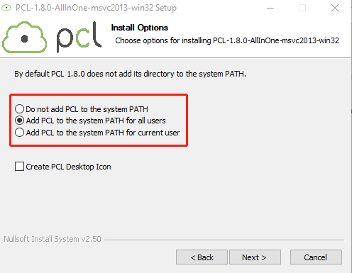

qt-opensource-windows-x86-msvc2013-5.5.1 to install Qt library

in your computer (default setting).

* Add new environment variables

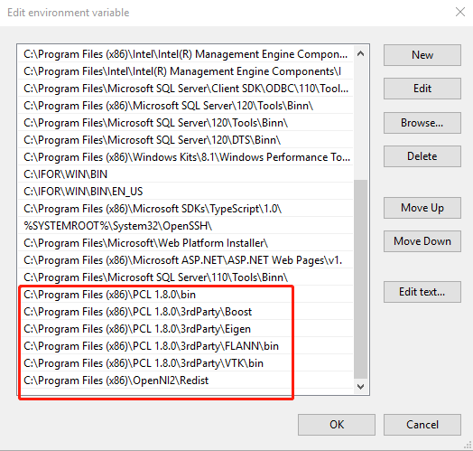

* Go to D:\ITF\Surface\_approximation\iRANSAC\, use VS2013 to open SmartOrthodontics.

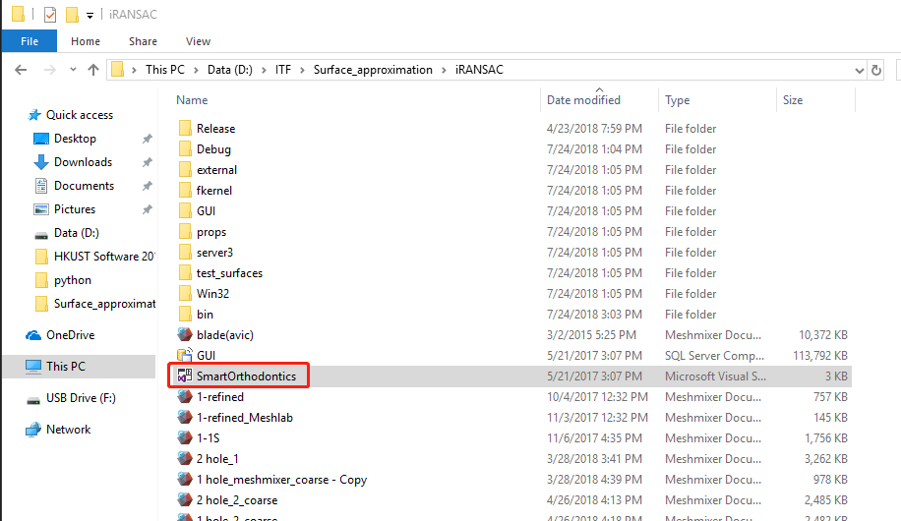

In this solution, click this button:

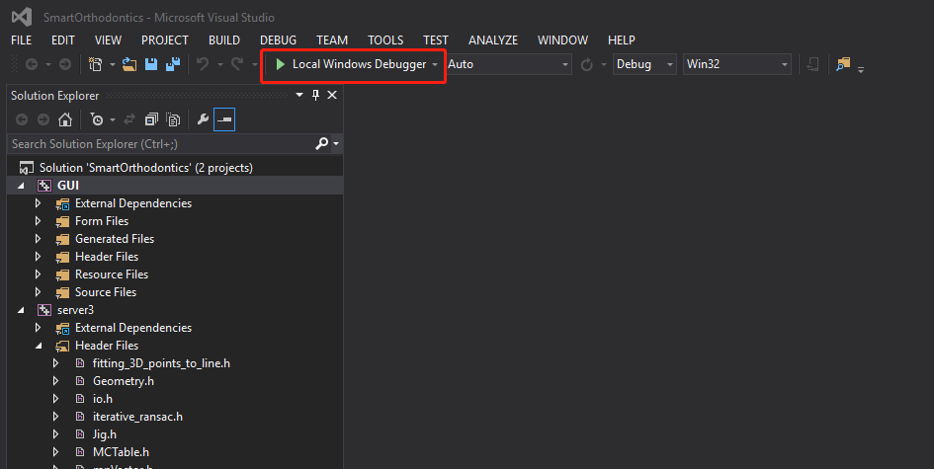

You might have this problem: error C4996 'pcl::SAC\_SAMPLE\_SIZE'

You should go to [Properties] -> [C/C++] -> [General] -> [SDL checks], and set it as No.

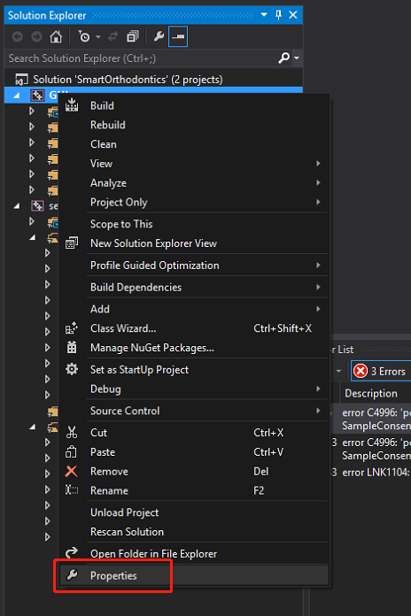

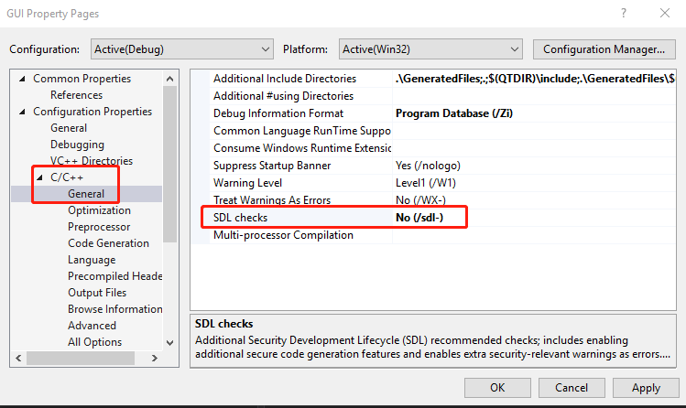

Double click this error and go to model\_types.h file and modify some codes like this:

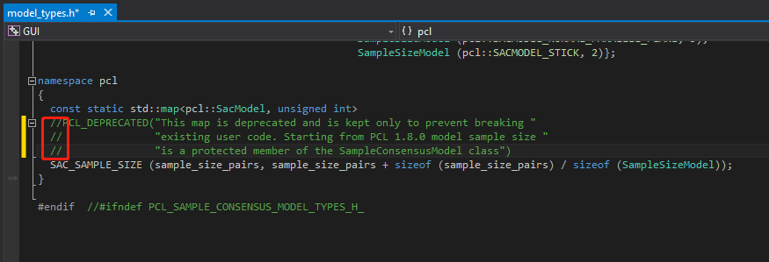

Then you can run this program smoothly.

### **CATIA optimization**

* The “VBAProject1.catvba” file is an integrated file, which contains all the macros needed to do the implementation. The users should load this file in CATIA by open it in Visual Basic Editor (Tools 🡪 Macros 🡪 Visual Basic Editor)

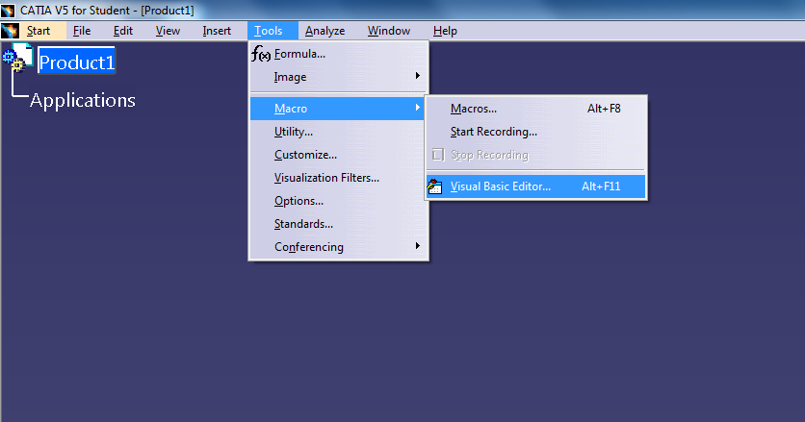

If there is no other projects loaded in the VB Editor, click “yes” if CATIA asks whether open or create a new one. Then, add the “VBAProject1.catvba” file in.

If there are other projects loaded, import the project from “file“ –> “import file”

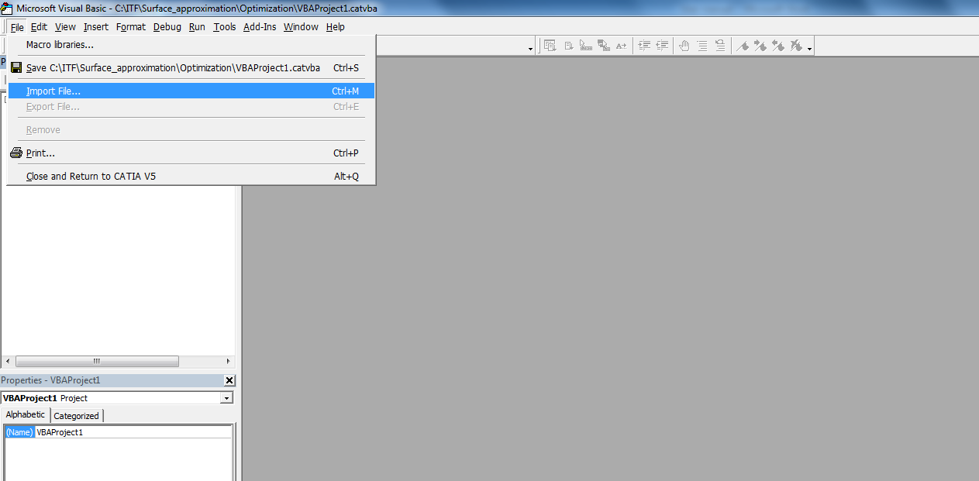

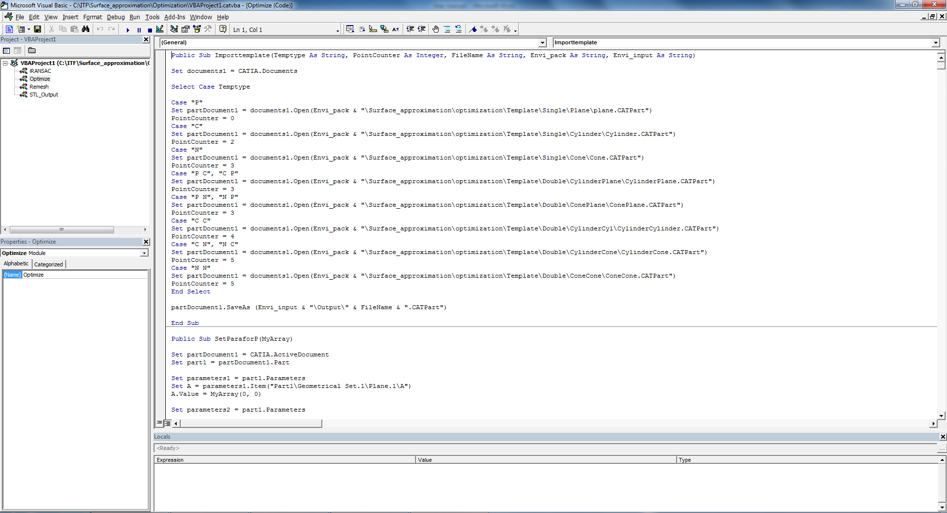

* Create Toolbar & Commands

1. Add "Surface approximation" toolbar to “Generative Shape Design” workbench.
2. Click [Tools --> Customize...], Select Toolbars from tab menu.

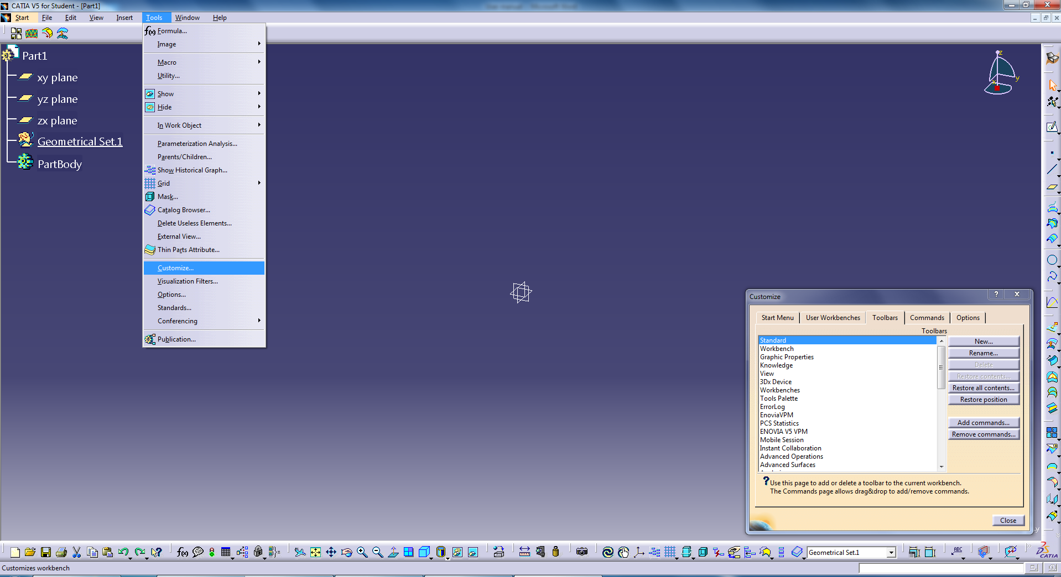

1. Click "News...", input " Surface approximation " as Toolbar Name.

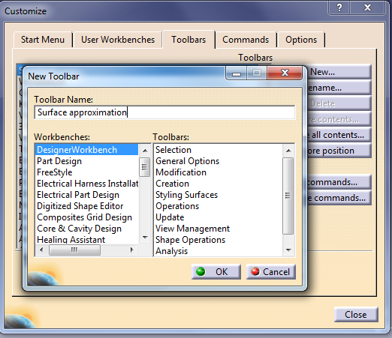

1. An empty tool bar was created.
2. Add Macros to the toolbar.
3. Click [Tools --> Customize...], Select Commands from tab menu.
4. Select Macros from categories.

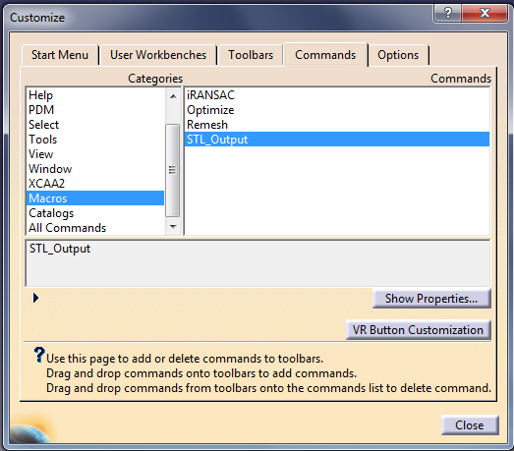

1. Choose "STL\_ouput", click "show Properties".
2. Click [C:\Users\AMI\Downloads\Catia_API UserGuide-20180725T053832Z-001\Catia_API UserGuide\image\icon_icon.jpg], locate []; Pick it.
3. Drag and drop the " STL\_ouput " onto the tool bar.
4. Repeat the iii)-v) for the Remesh , iRANSAC  and Optimize 
5. Result



## **Drawing Automation**

### **Prerequisite conditions**

#### **Installation of the software**

To run the package, the following software should be properly installed, including all the API functions:

SolidWorks 2016

Microsoft Excel

#### **Setting of the software**

1. Open “Option”, go to “General”, untick “Input dimension value”, click “OK” to finish setting.

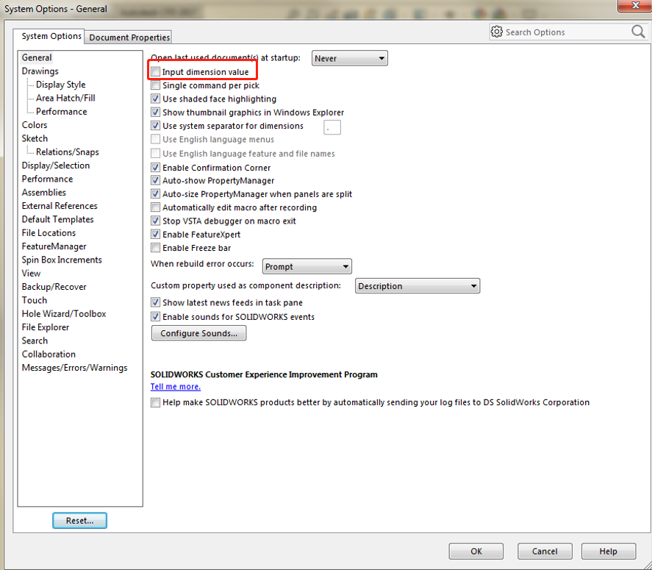

1. Open “Option”, go to “Sketch”, go to Relations/Snaps, untick “Enable snapping”, click “OK” to finish setting.

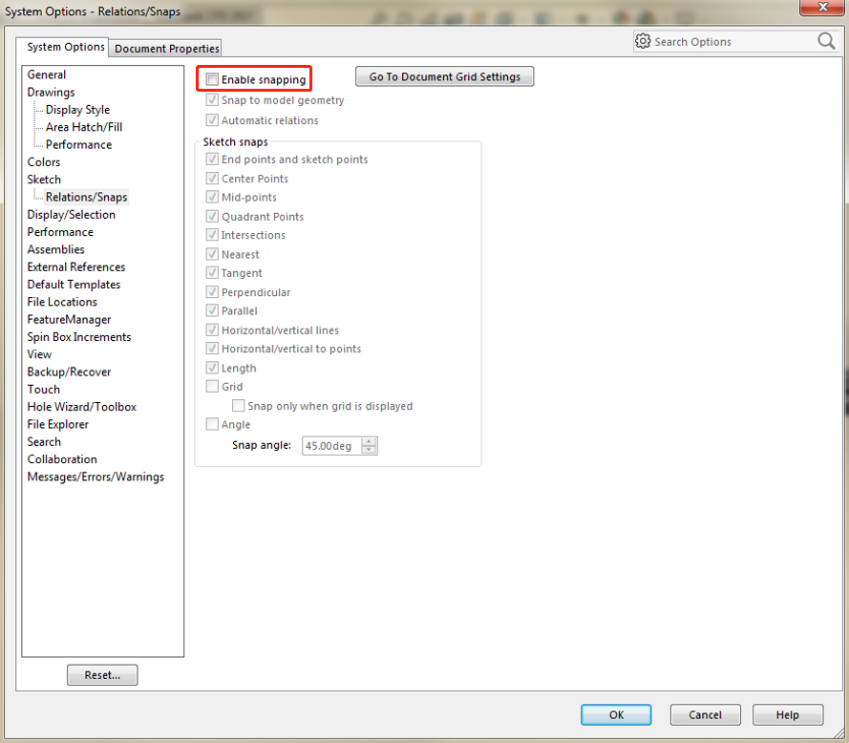

1. Right click the empty space on the toolbar, and enable “Macro”.
2. Click on “New Macro”, create a new file and copy the code to the new Macro file, or

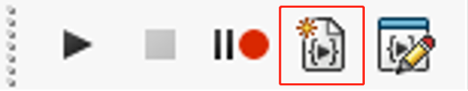

Right click the empty space on the toolbar, go to “customize…”, go to “Commands”, select “Macro”, drug “New Macro Button” to toolbar, to get a new Button.

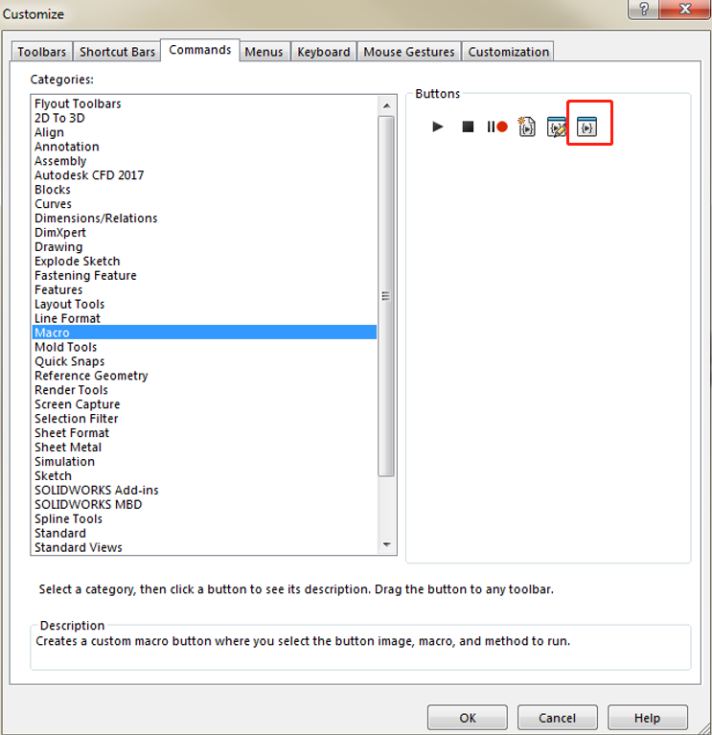

A interface as below will show up, select the Macro file (SWP) file, name it and click “OK” to create a user defined function.

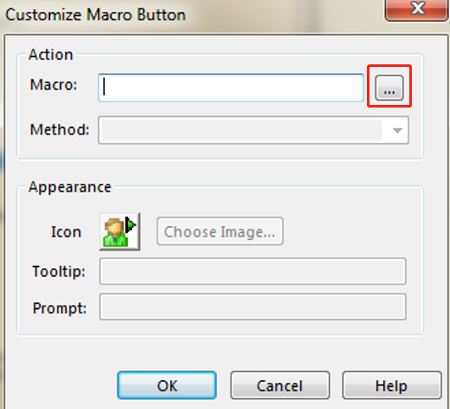

#### **Control Excel in SolidWorks Macro**

Step1: Open up a new VBA macro in SolidWorks

Step2: In the VB Editor, go to Tools–>References

Step3: Locate “Microsoft Excel 16.0 Object Library”, click the check box next to it, then click OK on the References dialog box.

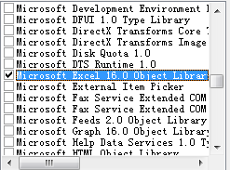

#### **Set path of the files**

Note all the default file paths are in the same document for the convenience of drawing automation process.

**Method 1:**

* **For Panels:**

Input file path: Drawing\_automation\Panels\FN. Output file: Drawing\_automation \Panels\Drawings, FN=file name, which should be corresponding panel type name: e.g., Panels, Single panel, Flat-cone, Flat-cone-flat, Flat-cylinder, and Flat-cylinder-flat.

* **For mullions:**

Input file path: Drawing\_automation \Mullions\FN. Output file: Drawing\_automation \Mullions\Drawings, FN=file name, which should be Mullion-n (n refers to integers).

* **For excel sheet:**

Input file path: Drawing\_automation \Panels/Mullions\Non-graphical information.

**Method 2:**

* **For panels:**

Note all the default file paths are in the same document for the convenience of drawing automation process.

Input file path: UDP\Panels\FN. Output file: UDP\Panels\Drawings

UDF=user defined path (which can be varies according to users, initial UDF is XXX\ITF-Demo, which can be all replaced by new UDF), FN=file name, which should be corresponding panel type name: e.g., Panels, Single panel, Flat-cone, Flat-cone-flat, Flat-cylinder, and Flat-cylinder-flat. Below shows an example:

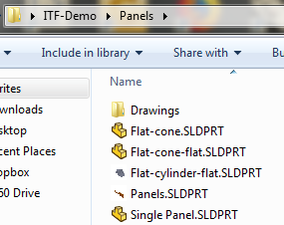

* **For mullions:**

Input file path: UDP\Mullions\FN. Output file: UDP\Mullions\Drawings

UDF=user defined path (which can be varies according to users, initial UDF is XXX\ITF-Demo, which can be all replaced by new UDF), FN=file name, which should be Mullion-n (n refers to integers). Below shows an example:

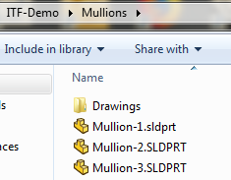

* **For excel sheet:**

Input file path: UDP\Panels/Mullions\Non-graphical information, the example contents of the excel file are shown below:



#### **Specifications/requirements of the models**

* **For panels:**

Only six types of panels are considered, which are, flat panels (named Panels or Single panel) twisted panels (named Panels or Single panel), flat-cone, flat-cone-flat, flat-cylinder, and flat-cylinder-flat. Specific modifications may be required for the program to be applied to other shapes of panels. Note that for flat-cone/cylinder types of panels, the joint panels should consists of four edges.

* **For mullions:**

The program is primary set for the models with the top view along the positive side of Y-axis and the length along X-axis. The only considered features are the holes or arc curves.

### **Outputs of the program**

#### **Run the program**

* **For panels:**

Step 1: Open the model files for panels

Step 2: Click the customized button created before:

e.g., 

* **For Mullions:**

Step 1: open any file

Step 2: Click the customized button created before:

e.g., 

#### **Output of the fabrication drawings**

* **For panels:**

the drawings will be automated generated along with PDF, DWG format in the file path: UDP\Panels\Drawings.

e.g,

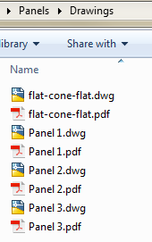

* **For Mullions:**

the drawings will be automated generated along with PDF, DWG format in the file path: UDP\Mullions\Drawings

e.g.

